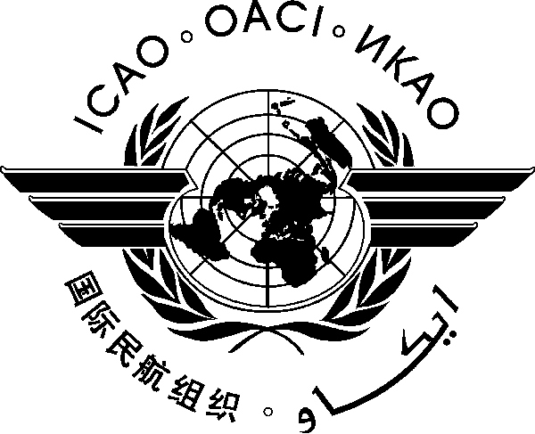 | International Civil Aviation Organization  WORKING PAPER
  ACP WG-F/25 WP-11 rev
  07/06/05

AERONAUTICAL COMMUNICATIONS PANEL (ACP)

25th MEETING OF THE WORKING GROUP F

Dakar, Senegal 6 – 14 October 2011

Agenda Item 2: | Review, update and development of the ICAO Frequency Spectrum Handbook

Common Signalling Channels for VDL Mode 4

(Presented by Larry Johnsson)
(Prepared by Robert Witzen and Larry Johnsson)

SUMMARY
This paper is proposing the identification of two common signalling channels for VDL Mode 4.
ACTION
Action by the meeting is in paragraph 4.

- INTRODUCTION
  - Frequency assignment planning criteria for VDL Mode 4 operating in the frequency bands 117.975 – 137 MHz and 112.000 – 117.975 have been completed by the ACP and the NSP respectively. This would enable to introduce Global Signalling Channels for VDL Mode 4 while protecting the current usage of these bands.
  - VDL Mode 4 is the ICAO Standard data link that provides for ADS-B and air/ground point-to-point communications. VDL Mode 4 interfaces with the ATN/IPS transport layer protocols and provides a seamless connection with the IPS based ATN. To facilitate global interoperability global signalling channels, one in the band 112.000 – 117.975 MHz and one in the band 117.975 – 137 MHz, are necessary. The need for two VDL Mode 4 Global Signalling Channels is identified in the VDL Mode 4 Technical Manual to increase the system redundancy and because of capacity reasons.
  - The NSP has completed its work on developing frequency assignment planning criteria for VDL Mode 4 operating in the band 112 – 117.975 MHz that protect ILS, VOR and GBAS systems also operating in (or adjacent to) this band. These planning criteria stipulate that no frequency assignment planning constraints exist for VDL Mode 4 operating on the 2nd adjacent 25 kHz channel from an ILS, VOR or GBAS frequency.
In summary of the frequency assignment planning criteria stipulate:
VOR and VDL Mode 4
Co-frequency and first adjacent (25 kHz) frequency: The separation distance between a VDL Mode 4 transmitting station and a VOR receiving station shall be greater than the distance to the radio horizon between the two aircraft operating at maximum range and height of their respective designated operational coverage (DOC) area.
Second adjacent 25 kHz frequency and higher: No frequency assignment planning constraints.
ILS and VDL Mode 4
No frequency assignment planning criteria are necessary for the protection of airborne ILS Localizer receivers from harmful interference from VDL Mode 4 transmissions
Interactions between GBAS and VDL Mode 4
Co-frequency use of GBAS and VDL Mode 4: The D/U ratio should be 20 dB. VDL Mode 4 equipped aircraft and VDB GBAS equipped aircraft should be separated to a distance beyond the radio horizon of the two aircraft.
1st adjacent (25 kHz) channel) VDL Mode 4 equipped aircraft should not operate within each DOC plus a buffer of 10 NM.
2nd adjacent channel and higher: No frequency assignment planning constraints between VDL Mode 4 and GBAS frequency assignments
- discussion
  - In Europe, the frequency 136.925 MHz has been assigned for pan-European use as VDL Mode 4 signalling channel. It is proposed that this frequency be coordinated with other ICAO Regions to satisfy the need for identification of the VDL Mode 4 Global Signalling Channel in the frequency band 117.975 – 137 MHz.
  - The frequency 116.550 MHz is proposed to provide the Global Signalling Channel for VDL Mode 4 in the band 112 – 117.975 MHz. On a global basis, this frequency is currently not being used for VOR or GBAS.
  - In order to secure compatibility of the proposed Global Signalling Channels for VDL Mode 4, it is proposed that these frequencies are being coordinated with the ICAO Regional Offices. Eventually, these will become the two VDL Mode 4 Global Signalling Channels.
  - Proposed modification to Annex 10. Volume V, Chapter 4.
4.1.3.3 Common Signalling Channel for VHF Datalink Mode 2 (VDL Mode 2). The frequency 136.975 MHz is reserved on a worldwide basis to provide a common signalling channel (CSC) to the VHF Digital Link Mode 2 (VDL Mode 2). This CSC uses the VDL Mode 2 modulation scheme and carrier sense multiple access (CSMA)
4.1.3.4 Common Signalling Channels for VHF Datalink Mode 4 (VDL Mode 4). In areas where VDL Mode 4 is implemented, the frequencies 136.925 MHz and [xxx.xxx] MHz shall be provided, as required, as common signalling channels (CSC) to the VHF Digital Link Mode 4 (VDL Mode 4). This CSC uses the VDL Mode 4 modulation scheme.
- Updates of VDL MoDE 4 ACTIVITIES
  - VDL Mode 4 supporting ATN/IPS
    - As part of the support to ICAO ACP WG-I work on developing ATN/IPS, VDL Mode 4 has been used to develop, verify and validate several IP components. This process included establishment of a VDL Mode 4 ATN/IPS based ground infrastructure in Sweden and a number of airborne installations allowing end-to-end exchange of messages using IPS protocols.
    - A special version of mobility, called “Ground NEMO” was developed and proven to be very efficient. Latest tests show that the use of compression algorithms significantly increases the capacity. This leads to the conclusion that ATN/IPS can be implemented over a narrow band data link like VDL Mode 4 capable of supporting the development of new data link services and providing early benefits to airspace users.
    - The VDL Mode 4 ATN/IPS infrastructure is now used in the SESAR project for validation. VDL Mode 4 is being recognised as the only ground based air-ground data link supporting ATN/IPS that is standardised by aviation. VDL Mode 4 is fulfilling the requirements for “SWIM Air-Ground Capability” defined by SESAR. VDL Mode 4 is also recognised as a “link candidate for AIS/MET Data Link Services by the RTCA SC206. Recent demonstrations show that VDL Mode 4 ATN/IPS supports communication of Volcanic Ash messages
  - VHF Multi Mode Radio (VMMR)
    - After extensive studies of co-site interference between systems onboard aircraft, the conclusion is that implementation of VDL Mode 4 on-board aircraft is feasible. New radio developments like VHF Multi Mode Radios (VMMR) provides new possibility to handle onboard interference as operation of several radios would be coordinated within the on-board radio.
    - In the VMMR, VDL Mode 4 would be one of several systems providing connectivity to various communication systems depending on what services are provided in the actual area. The VMMR would be a replacement of existing VHF radios onboard aircraft, minimising the traditional transition problems as they are very suitable for both retrofit and new-fit.
    - The VMMR that is in its final stage of development include radios supporting ACRAS, VDL Mode 2, VDL Mode 4 and DSB/AM voice.
  - New initiatives
    - Several initiatives should be recognised leading to innovative and new applications/services utilising the capabilities of VDL Mode 4.
    - A Wake Vortex warning system has been developed in Russia allowing both pilots in aircraft and controllers in ATC to get a visualised picture of the Vortex on their displays, thus providing the controller a possibility to avoid guiding aircraft into vortex, but also giving pilots the possibility to avoid hazardous situations caused by wake vortex.
    - The aviation community is spending a lot of effort on allowing unmanned aircraft (UAS) to operate in non-segregated airspace together with manned aircraft with pilots onboard. A solution based on VDL Mode 4 has been presented to ICAO Unmanned Aircraft Systems Study Group (UASSG) that has the potential to allow unmanned and manned aircraft operate in the same portion of airspace in a robust and safe way.
    - It has been identified that it would be very beneficial to distribute AIS and MET information digitally to aircraft. VDL Mode 4 has been used to demonstrate the feasibility of such a solution. Sometimes this is considered to be part of SWIM.

- ACTION BY THE MEETING
  - The meeting is invited to:
    - Invite the Secretariat to coordinate with the ICAO Regional Offices the common signalling channels for VDL Mode 4
    - Review the proposed amendment to Annex 10, Volume V on the introduction of provisions for the VDL Mode 4 Common Signalling Channels.
- - - - - - - -

